**PROJECT-NAME: TASTY BURGER**

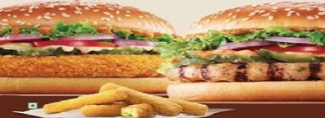

1. **HOME PAGE:**

# LOGO

# ADD TO CART

# LOGIN

# OUR MENU

# SLIDERS WITH ARROWS - (IMAGES)

# FAVOURITES- (IMAGES)

# FOOTER – (ABOUT, CONTACT US, TERMS AND CONDITION,

SOCIAL-MEDIA ICONS)

**2. LISTING PAGE:**

# FILTERS - (FOOD TYPE, MENU TYPE, COST)

# IMAGES OF THE CHOSEN PRODUCT WITH DETAILS LIKE -

(PRODUCT NAME, PRICE )

**3. DETAIL PAGE:**

# PRODUCT DESCRIPTION - (PRODUCT NAME ,

PRICE, SIZE CHART, PRODUCT

DETAILS, RATINGS, CUSTOMER REVIEWS

WITH IMAGES)